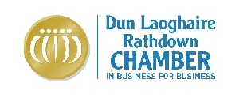

In conjunction with Bray and District Chamber

has pleasure in inviting you to a

Budget Breakfast Briefing

at the

Bewley’s Hotel Leopardstown

Wednesday 7th December 2011
7.30 am (registration opens at 7.15 am)

€10 for Members, €20 for non-members

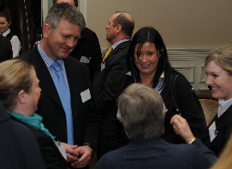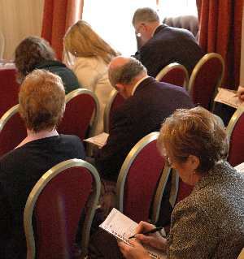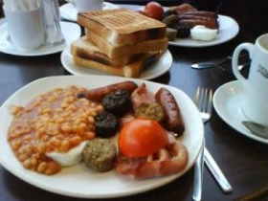

John Bainbridge, Head of Tax Services for MKO Partners will take you through the newly released national budget, describe its impact on business and answer your questions. At the same time you can share a Full Irish Breakfast with business people operating from Dublin to Wicklow. This is a great opportunity to learn what the budget means for you and at the same time develop and expand your network of business connections!

Both Chambers would like thank to our generous sponsor:


To assist with catering we would appreciate early confirmation of attendance
. . . . . . . . . . . . . . . . . . . . . . . . . . . . . . . . . . . . . . . . . . . . . . . . . . . . .

B O O K I N G F O R M

Name: ______________________________________________ Tel: ____________________________

Company Name: _______________________________________________________________________

Email: ____________________________________________ Tel. No. ___________________________

Name/s of guest/s (if any): ______________________________________________________________

Member (yes/no) _________ Number of attendees ________ Cost __________

Payment by cheque, credit card or bank transfer unless otherwise arranged.

Permission to Share Email Address: The Chamber endeavours to give participants a list of the names, firms and e-mail addresses of the attendees. If you do not want your information shared and do not want to receive the list, then please check this box.

Please contact: Loredana McHugh, Dun Laoghaire Rathdown Chamber
1 Haigh Terrace, Dun Laoghaire, Tel: 284 5066 Fax: 284 5034 Email: loredana@dlrchamber.ie

